Virtual Network(MyVnet):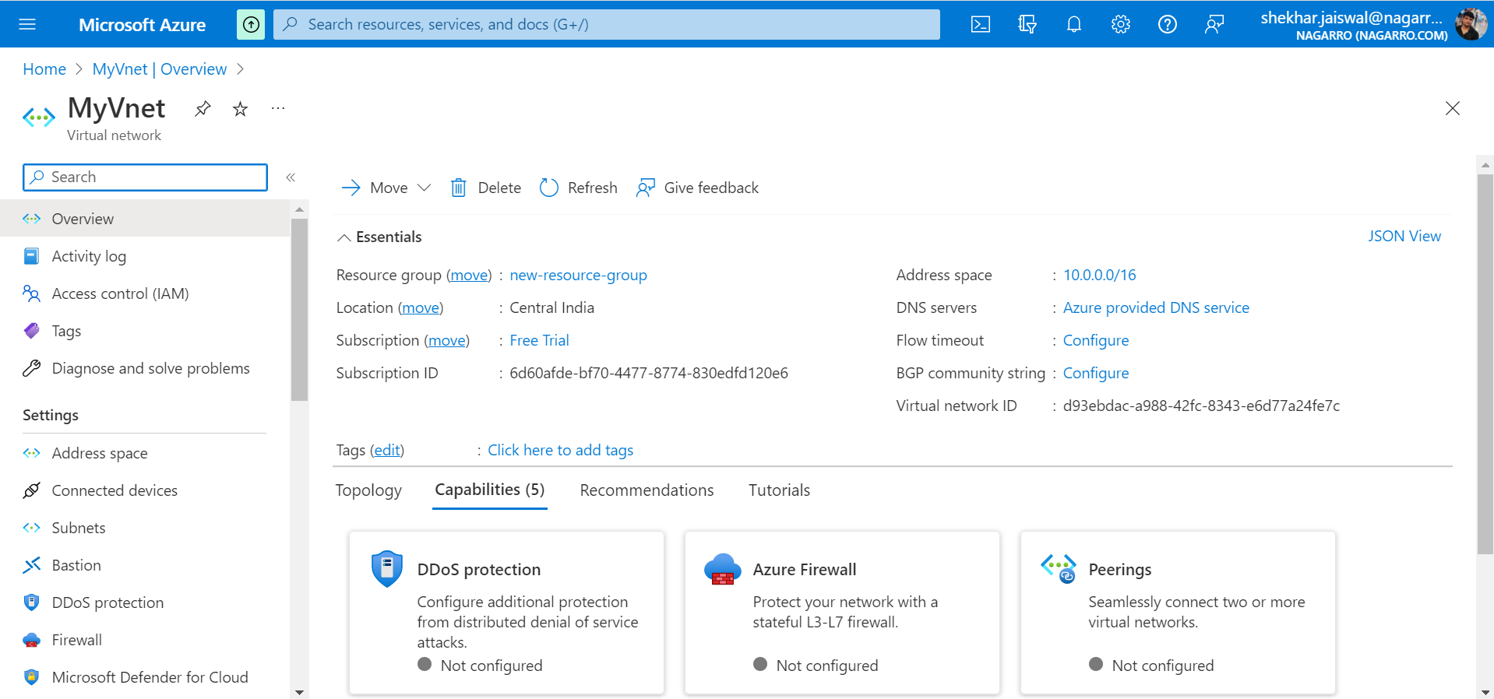

Total Ips= 16(11 available and 5 reserved)

Creating vm-2 with ssh authentication:

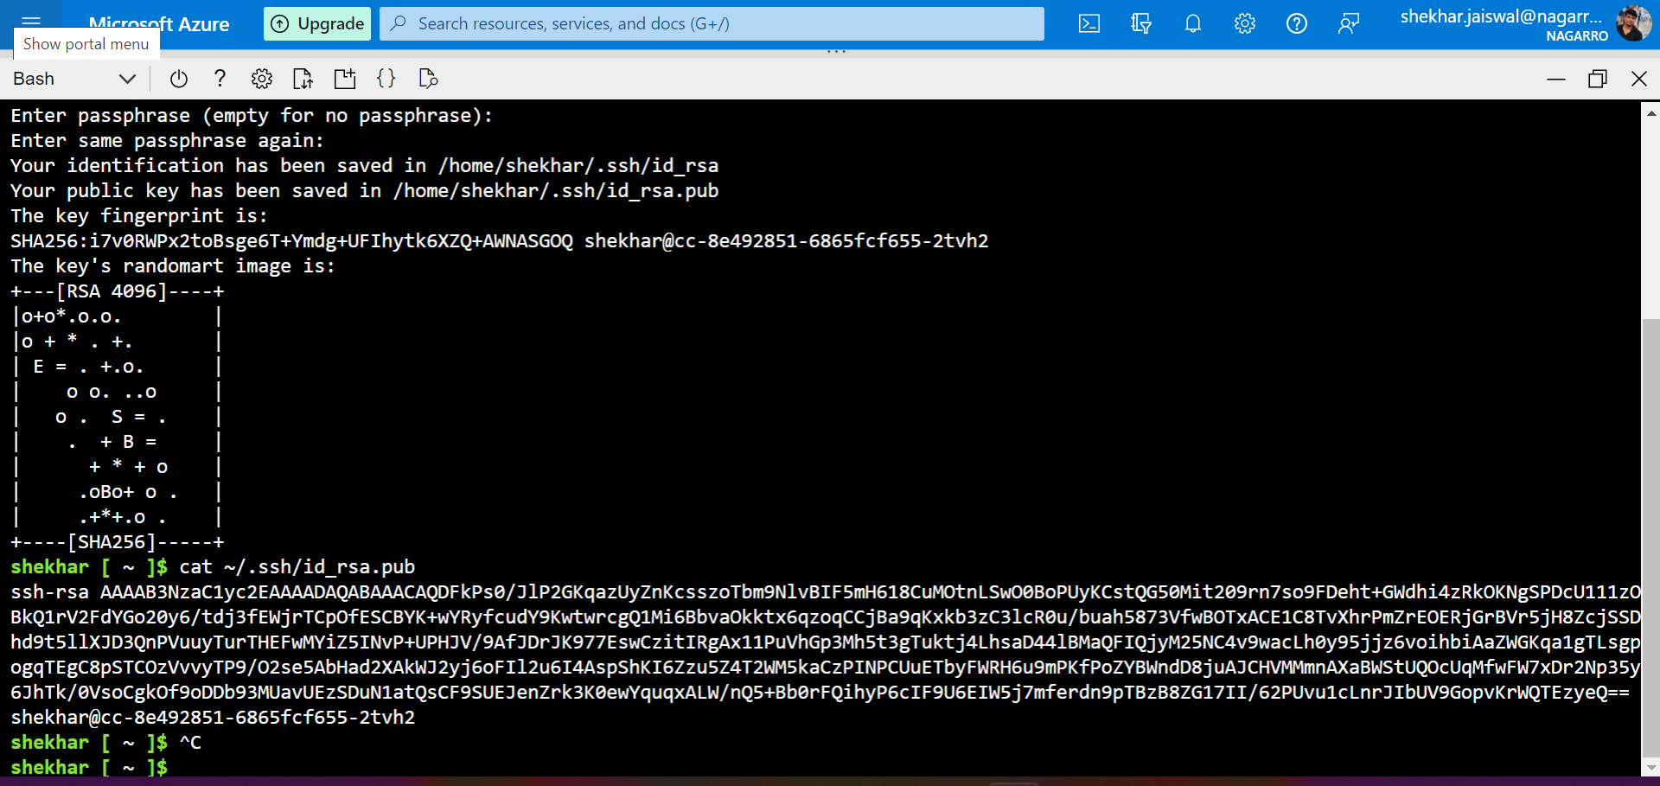

VM-2:

Hosted an asp.net core web application on vm1

Azure Sql Db:

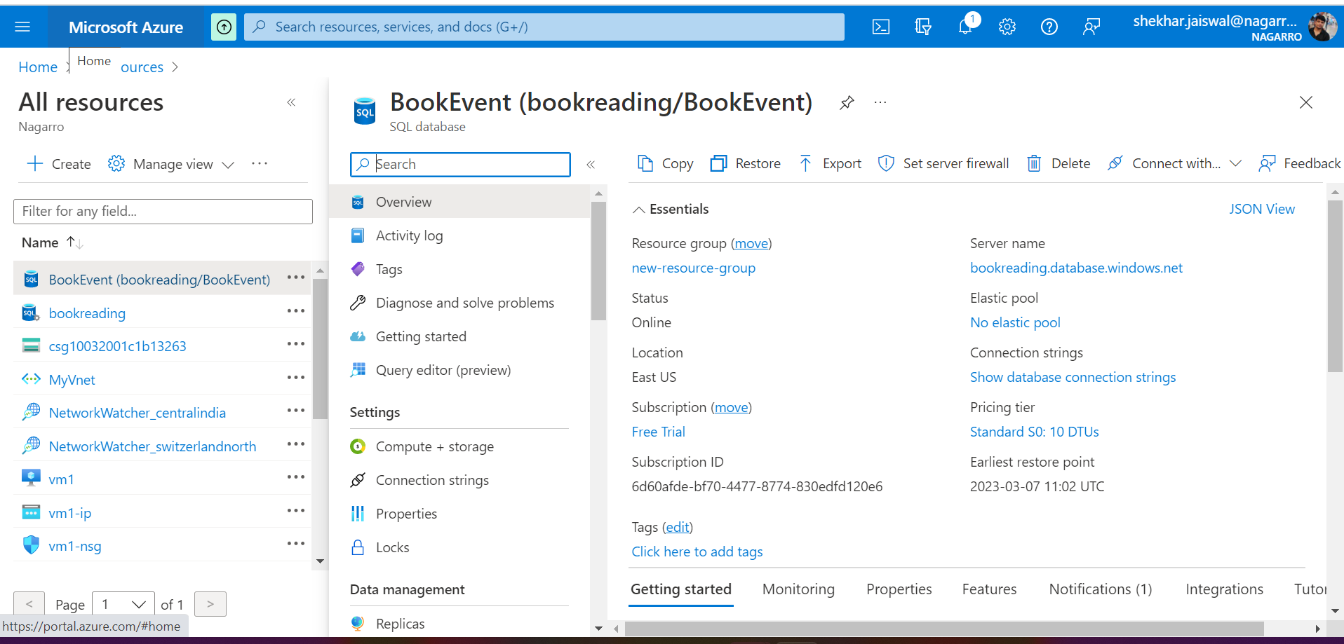

Deploying same web application on Azure app service:

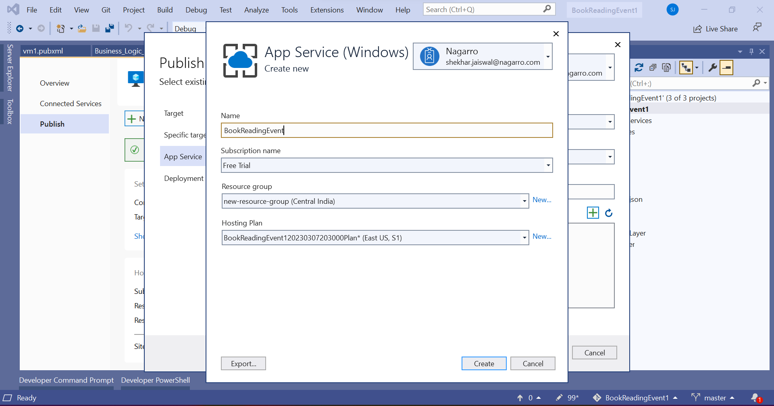

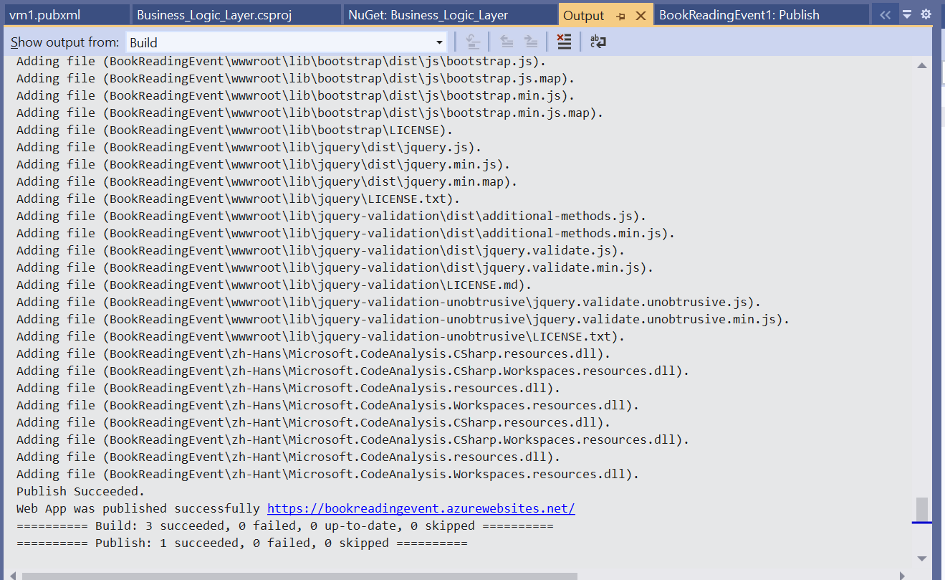

Application Homepage:

Kubernetes Cluster with 2 Nodes:

Service deployed on kubernetes

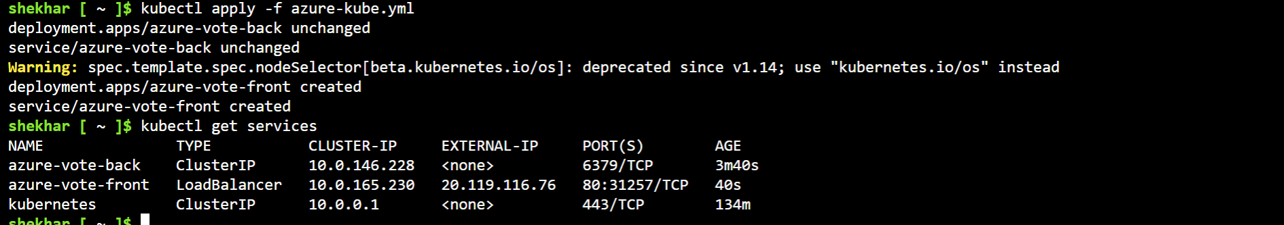

Deployed service homepage:

create Blog trigger function in function App (blobfunctionappp) name: BlobTrigger

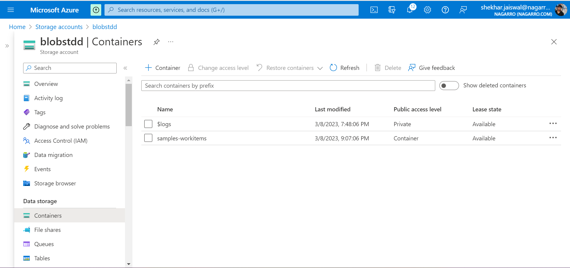

then again go into Blogtrigger and select code + test and upload file in container

result is highlighted part`

